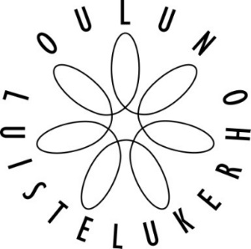

IC Oulu Skate 2019
21.-22.9.2019

Planned program for ISU categories, single skating

Club, country:
Category:
Skater:
Music (theme) - short program:
Music (theme) - free skating:

time | Elements Short Program |  | time | Elements Free Skating

Date, Signature

